Appendix 2 – Gear and Equipment Compliance

2021 State Championships Hull Check List
Club Name: |  |  | Date:
Club Contact: |  |  | Contact Details:
(Name of Person Responsible for Equipment) |  |  | (Mobile Number)

IRB Hull Details
Hull Make & Model: |  |  | Registration Number: SR______________
(Class 3 IRB’s Not Accepted)  HULL AND FUEL CELL MUST BE PERMANENTLY MARKED WITH CLUB IDENTIFICATION THAT WILL NOT WASH OFF.  HULLS FOUND TO HAVE UNDERLYING DEFECT AFTER INSPECTION MAY HAVE INSPECTION FAILED. |  |  | NO RESPONSIBILITY WILL BE TAKEN FOR ITEMS NOT PERMANENTLY MARKED WITH CLUB IDENTIFICATION  ALL EQUIPMENT MUST HAVE PASSED RECENT GEAR INSPECTION AND ENTERED IN SURFGUARD GEAR AND EQUIPMENTM LIST.
Please circle the following:  Permanently Marked Club Identification Yes No  Hull Appearance: Clean Dirty  Safety Equipment removed: Pass Fail  Crewmen’s’ bow rope: Pass Fail  Crew and Driver handlers: Pass Fail  Lifeline ropes and eyelets: Pass Fail  Foot Straps: Pass Fail  Floor Board/ RIB Hull Condition: Pass Fail  4 x Side Lift Handles: Pass Fail  Front Lift Handle: Pass Fail  Pontoons & Keel holding pressure Pass Fail  Engine Safety Cable on Hull: Pass Fail  Visible Hull Wear: Pass Fail  Pre-Use Hull Inspection: Pass Fail  Re – Inspection Date:___________________ Pass Fail |  |  | Reason .  Reason .  Reason .  Reason .  Reason .  Reason .  Reason .  Reason .  Reason .  Reason .  Reason .  Reason .  Reason ____________________________________

DROP OFF - IRB HULL INSPECTION PASSED BY: DATE:
PICK UP - IRB HULL INSPECTION ACCEPTED BY CLUB  Name: Date: |  |  |  |  | YES / NO  Mobile: __________________________
Comments:

IRB HULL INSPECTION SHEET

IRB HULL AND FUEL CELL MUST BE PERMANENTLY MARKED WITH CLUB IDENTIFICATION THAT WILL NOT WASH OFF. NO RESPONSIBILITY WILL BE TAKEN FOR ITEMS NOT PERMANENTLY MARKED WITH CLUB ID.
HULLS FOUND TO HAVE UNDERLYING PROBLEMS AFTER INITIAL INSPECTION MAY HAVE INSPECTION FAILED.

IRB HULL PERMANENTLY MARKED: YES / NO, MARK ANY EXISTING WEAR / DAMAGE: OK / FAIR / FAIL
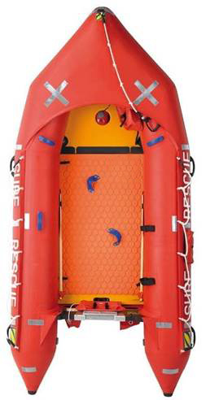

2021 State Championships Engine and Fuel Cell Check List
Club Name: |  |  |  | Date:
Club Contact: |  |  |  | Contact Details:
(Name of Person Responsible for Equipment) |  |  |  | (Mobile Number)

IRB Engine Details
Engine Make & Model: Tohatsu M25 / Mercury ME25 circle |  |  |  | Manufacturer Engine Serial Number:
(Yamaha 25XMHS NOT ACCEPTED, Product has ceased)  ENGINE, ENGINE COWL & FUEL CELL MUST BE PERMANENTLY MARKED WITH CLUB IDENTIFICATION.  ENGINE or CELL FOUND TO HAVE UNDERLYING DEFECT AFTER INSPECTION MAY HAVE INSPECTION FAILED. |  |  |  | NO RESPONSIBILTY WILL BE TAKEN FOR ITEMS NOT PERMANENTLY MARKED WITH CLUB IDENTIFICATION. ALL EQUIPMENT MUST HAVE PASSED RECENT GEAR INSPECTION AND ENTERED IN SURFGUARD GEAR AND EQUIPMENTM LIST.
Please circle the following:  Permanently Marked Club Identification Yes No  Engine Appearance: Clean Dirty  Engine Safety Cable on Engine: Pass Fail  Spark Plugs and Leads: Pass Fail  Choke Operation: Pass Fail  Throttle Operation: Pass Fail  Recoil Cord and Operation: Pass Fail  Engine Cowl Fitting Properly: Pass Fail  Prop Guard and 4 Blade Prop: Pass Fail  Fuel Cell, Hose, Fittings & Club I.D: Pass Fail  Engine Start and Run in Tank: Pass Fail  Visible Engine Wear: Pass Fail  Pre-Use Engine Inspection: Pass Fail  Re – Inspection Date: _____________ Pass Fail |  |  |  | Reason____________________________________  Reason____________________________________  Reason ____________________________________  Reason ____________________________________  Reason ____________________________________  Reason _ __  Reason __ _  Reason _ __  Reason _____________________________________ Reason ___________________________________  Reason _____________________________________  Reason ____________________________________  Reason _____________________________________

DROP OFF – ENGINE & CELL INSPECTION PASSED BY: Date:
PICK UP  IRB Engine & Cell Inspection Accepted By Club  Name: Date: |  |  |  |  | YES / NO  Mobile: _______________________
Comments:
IRB Motor Inspection

ENGINE, ENGINE COWL AND FUEL CELL MUST BE PERMANENTLY MARKED WITH CLUB IDENTIFICATION THAT WILL NOT WASH OFF. NO RESPONSIBILTY WILL BE TAKEN FOR ITEMS NOT PERMANENTLY MARKED WITH CLUB IDENTIFICATION.
ENGINE OR FUEL CELL FOUND TO HAVE UNDERLYING PROBLEMS AFTER INITIAL INSPECTION MAY HAVE INSPECTION FAILED.
MARK ANY EXISTING WEAR / DAMAGE OK / FAIR / FAIL

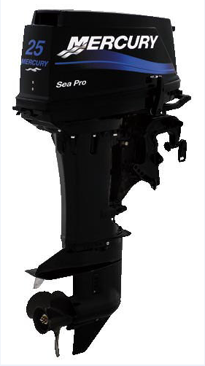

CLUB ID. ON COWL _______*

YES / NO

CLUB ID. ON ENGINE _________*

YES / NO

CLUB ID. ON FUEL CELL

YES / NO

