Memorandum

To: Directors, Branch Presidents/CEOs and Secretaries, Clubs, Members
Date: Thursday 24, March 2022
Pages: 3
Subject: Calling for nominations for Surf Life Saving New South Wales Standing Committees

The annual tenure anniversary for various Surf Life Saving New South Wales Standing Committees is approaching and the Surf Life Saving New South Wales Board of Directors is calling for nominations for the following Committee’s for a three-year term:

- Finance, Audit and Compliance Committee (FACC) 1 position
- Investment Advisory Committee (IAC) 1 position
- Life Saving Standing Committee (LSC) 1 position
- Risk Committee (RC) 2 positions
- Surf Sports Standing Committee (SSSC) 2 positions

The FACC, IAC and RC operate in accordance with their respective charters (attached). Each Committee is comprised of independent members, with a representative/s from the SLSNSW Board on each of the Committees.

As per the attached Charters, the Surf Sports Standing Committee is chaired by a member of the SLSNSW Board and is made up of the Surf Sports Director from each of the 11 Branches, and up to 5 independent members.
Similarly, the Lifesaving Standing Committee is chaired by the SLSNSW Director of Lifesaving (SLSNSW Board member) and is made up of the Lifesaving Director from each of Branch and up to five independent members.

Please be advised that nominations will be considered by the Surf Life Saving NSW Board of Directors. All appointments are for the terms indicated on the nomination form.

Candidates interested in expressing an interest for any position must be current financial members of Surf Life Saving NSW and should submit the attached signed nomination form, along with a typed copy of your resume (2 page maximum) which details your credentials and relevant experience for the position/s to assist the Board of Directors to make a decision about the suitability of the candidates for the position/s.

The attached nomination form needs to be forwarded to the Surf Life Saving NSW CEO by COB, Tuesday, 26 April 2022.

Yours sincerely
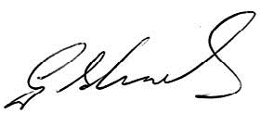
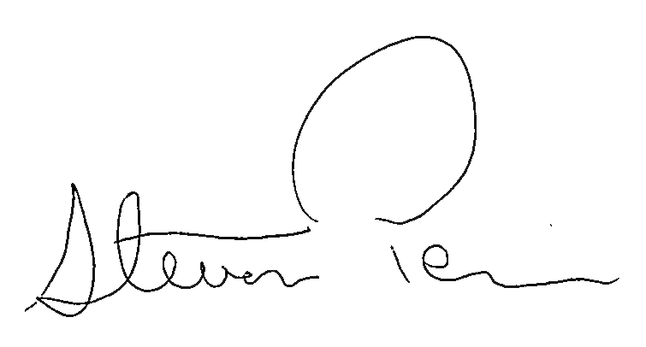

Steven Pearce AFSM George Shales OAM
Chief Executive Officer President
Surf Life Saving New South Wales Surf Life Saving NSW

Surf Life Saving New South Wales
Nomination Form for Standing
Committees

Name:

Address: Postcode:

Email:

Work Ph: Mobile Ph:

Club/s: Branch:

Please tick the position/s you wish to express an interest for:

Committees

Finance Audit and Complinace Committee (3 years)

Investment Advisory Committee (3 years)

Lifesaving Standing Committee (3 years)

Risk Committee (3 years)

Surf Sports Committee (3 years)

Nominee signature: …………………………………………………………........................................................................................

Date: ........................................

Nominations close at Surf Life Saving NSW at COB, Tuesday, 26 April 2022.

Please return this signed nomination form to Mr Steven Pearce AFSM, Chief Executive Officer, Surf Life Saving NSW, PO Box 307, Belrose, NSW, 2085 or via email: pa@surflifesaving.com.au

